Brief Report
Workshop on the SDGs and EFGR Evaluation
National Assembly of Cambodia, Phnom Penh, 18 November 2016

- Background
The National Assembly of Cambodia has been involved in global efforts in promoting the demand and use of evaluation findings in decision making through the participation of several members of parliament in a number of regional and global forms organized jointly by EvalPartner and UN agencies. Since October 2015, Cambodian MPs have actively attended the forum for development evaluation organized in October 2015 in Bangkok to officially launch the East Asian Parliamentarians Forum for Evaluation together with MPs from other countries in the region. As well as the Global Evaluation Week organized in Kathmandu from 23rd to 27th November in 2015, NA member H.E Pol Ham participated in the first Face-to-Face Meeting of the Steering Members in March 2016 focusing on “No one left behind – evaluating SDGs with an equity-focused and gender-responsive lens, EFGR”, as a steering member of the Global Parliamentarians Forum for Evaluation (GPFE). He was also featured in a video to advocate for the use of evaluation findings in decision-making disseminated through the GPFE’s website. Currently, H.E. Pol is attending the Asia Regional Consultation on EFGR National Evaluation Policies in Hanoi.
Given the advent of the Sustainable Development Goals (SDGs) and growing demands for accountability, Cambodian MPs are looking for opportunities to improve their knowledge of the global development agenda as well as how they as MPs could help the Kingdom to realize its localized sustainable development goals. Building on our history of collaboration with the MPs, including through the National Assembly Women’s Caucus and this Global Parliamentarians Forum for Evaluation, the National Assembly of Cambodia submitted a request to UN Women Cambodia Country Office (CCO) to deliver a half-day workshop on SGDs and EFGR Evaluation on November 18th to Parliamentarians from Commission 3 and other relevant bodies of the Assembly.

- Scope and Purpose of the workshop
With the request, UN Women CCO initiated a discussion with UNRCO in the country and Regional Evaluation Specialists of UN Women and UNICEF based in Bangkok. It was decided that this workshop would be facilitated by local experts in the local language with technical assistance and advice from the regional evaluation specialists.
The scope of the workshop focused on two requested topics: (1) definition and implications of each SDG goal in the context of Cambodia, and (2) Equity-Focus and Gender-Responsive Evaluation.
This workshop aimed to help MPs in reviewing national development strategies, plans and legislation and monitoring their effectiveness by equipping them with a broader understanding of the global development agenda and trends with a particular focus on integrating an equity and gender-responsive focus in their policy decisions.

- Objectives
The objectives of the workshop were to:
- Increase general understanding of MPs on the SDGs and their implications to Cambodia, as one of the member states who committed to this global agenda in September 2015 in New York; and
- Increase awareness of MPs on how evaluation, especially EFGR evaluation, is important for them to perform their role as a check and balance mechanism for the sustainable and equitable development of the country.

- Key Results
This was the first workshop for Cambodian MPs focused on SDGs and Evaluation. It generated a lot of interest from participating MPs, reflected in their very active discussion. The following points summarize key results observed:
- This workshop was attended by 19 MPs (4 female) from Commission 3 and Commission 8 of the assembly. Commission 3 focuses on “Planning, Investment, Agriculture, Rural Development, Environment, and Water Resources”, and commission 8 focuses on “Health Care, Social & Veterans' Affairs, Youth Rehabilitation, Labour, Vocational Training & Women's Affairs”. Sixteen staff of the two commissions also attended the session.
- Most comments we received from the MPs reflected that they had not previously heard about the either the MDGs or SDGs and they were very appreciative of this opportunity. One of the feedbacks received was that “we are just aware that most of our decisions made on policy and legislation were not based on rigorous evaluation findings, but were based on our personal judgement”, said one of the participating MPs. Another participant H.E. Sun Saphoeun, a senior woman MP who also attended the East Asian Parliamentarians in Strengthening Evaluation Function in National Development Agenda workshop in 2015 stated that: “this special session equipped me with more in-depth knowledge on the relatedness of SDGs and evaluation and the roles of MPs in making decision based on evidence generated from rigorous and credible evaluation”. Another woman MP who took part requested: “please let me know if there is another similar session in the future, so that I can learn and engage more in this important agenda”.
- MPs expressed the need for further training or similar kinds of session to go deeper on the subject, as well as to expand it to more MPs, as they felt that the subject is so relevant for Cambodia in general and for them as MPs in particular.
- A report on the session was broadcasting on the National TV channel (TVK or in Khmer called ទទក) and hosting on the National Assembly website. http://nac.org.kh/tv/kh/article/2348#.WDZbFbknJoH
A formal pre-test and post-test was not administered given that it might not be appropriate to do so with these senior people.

Pictures:
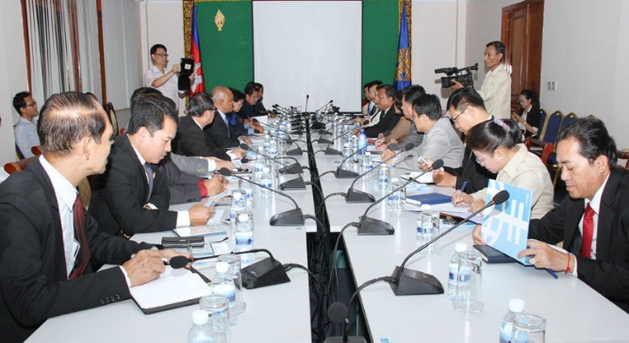 | 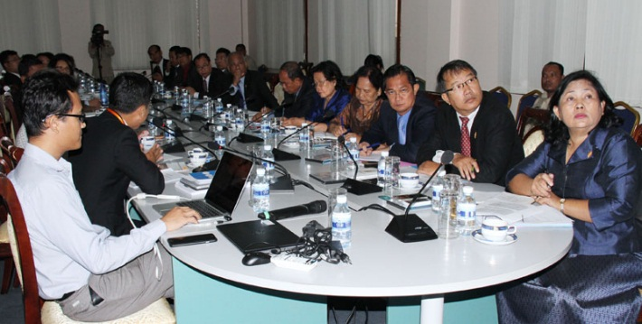
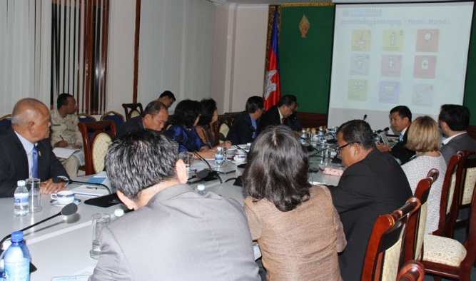 | 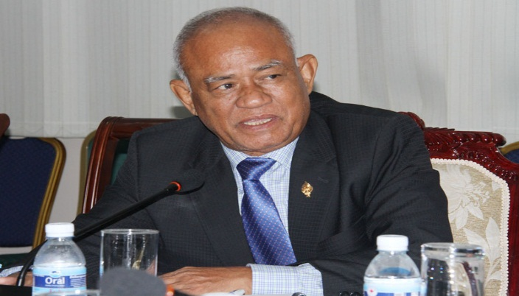
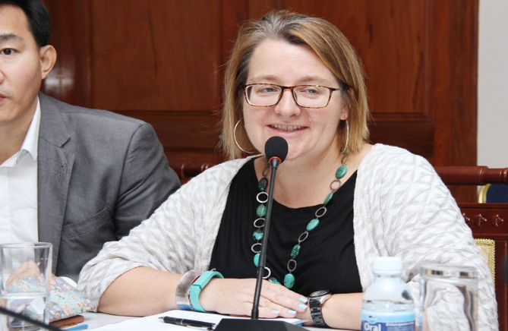 | 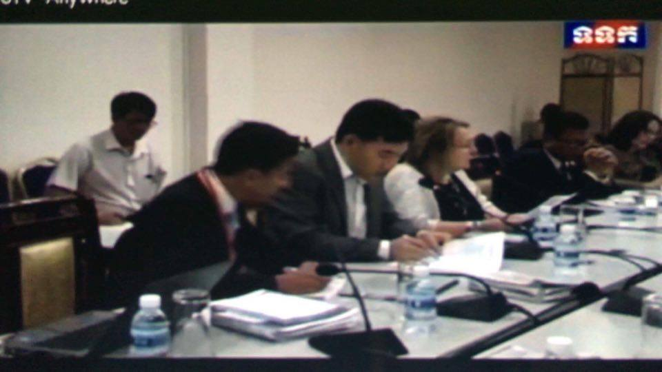
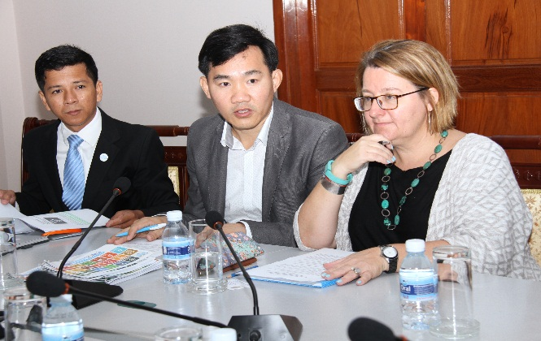 | 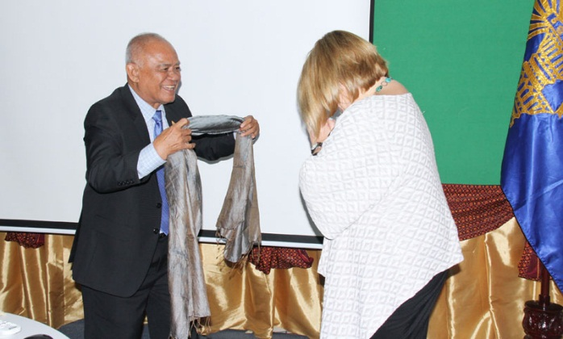

- Next steps

- Commission 3 is distributing the video clip on the SGDs and EFGR Evaluation to other MPs who were not able to attend the workshop, including those from the other eight commissions
- We will discuss further how to scale up of this capacity development initiative for MPs on these topics (1st semester 2017)
- The chairman of the commission 3, H.E Pol Ham will invite H.E Pagnathun Theng, director general of the Ministry of Planning, who is also the head of the national working group on monitoring and evaluation, to provide an update on the status of the localized SDGs formulation, as well as the overall status of development evaluation in the country (time yet to be established).

