**Kyrgyz Republic Parliament adopts a Concept on Evaluation of Laws, Programs, Resolutions**

On November 20, 2019, the National Parliament of the Kyrgyz Republic approved the Concept on Using Evaluation Tools to Carry out Parliamentary Supervision Functions.

The Parliament Resolution which approved the Concept was initiated by multi-party group of parliamentarians including Hon. Aaly Karashev (Social Democratic Party), deputy speakers Hon. Mirlan Bakirov (Onuguu-Progress Party) and Hon. Aida Kasymalieva (Social Democratic Party), and other parliamentarians.

The documents, including the Concept of Evaluation Use by Parliament, Methodological Guidelines for Evaluation of Laws and State Programs, was developed by parliamentarians together with local evaluation experts based on best international practice.

The document was discussed with representatives of civil society, government bodies and local governments. In 2019 the evaluation methodology was piloted by parliamentary committees with relation to the Law on Prevention of Offenses, Law on Protection from Family Violence, and Law on State Benefits.

Honorable Aaly Karashev, Kyrgyz Republic parliamentarian who was one of the initiators of the Evaluation Concept, noted in his presentation that the main objective is to make parliamentary supervision and control more effective and useful for the society. “Previously, reports from executive authorities focused on benchmarks and technical indicators that were understandable only to professionals and had limited relevance to the general population. The purpose of the evaluation is not only to show numbers and indicators, but, above all, to show how laws and programs impact the country, industry, and society. This is another step towards democratizing governance and increasing responsiveness and accountability of state bodies.”

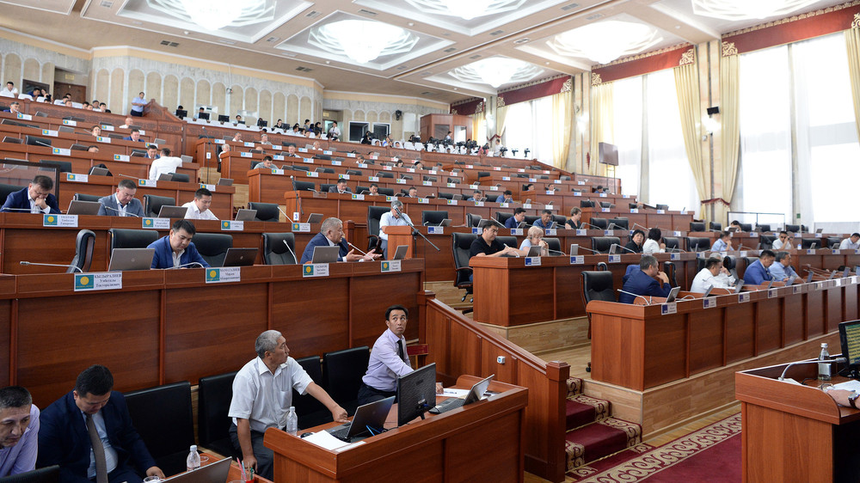

# Based on AKIPress article “Жогорку Кенеш принял концепцию по оценке действия законов, решений и государственных программ”, of November 20, 2019 retrieved from <https://kg.akipress.org/news:1578938/?from=akipress-android>