**Training for Emerging Evaluators of the Alassane OUATTARA University**

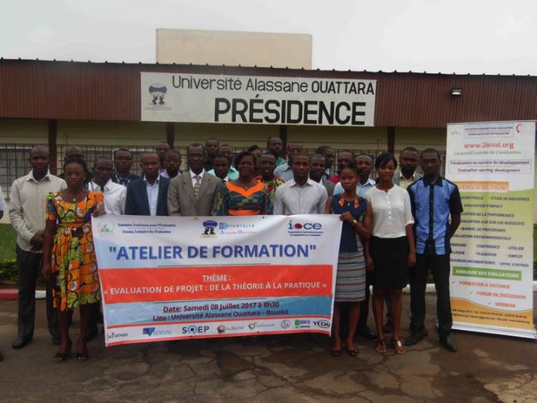

The Ivorian Initiative for Evaluation (2IEval), as part of the decentralization of its activities, organized a training on Saturday, July 08, 2017, at the Alassane Ouattara University in Bouaké, for 30 doctoral students on the theme: " Project evaluation: from theory to practice". This training is part of the series of trainings initiated for the Emerging Evaluators Thematic Group (GT-Ee).

The objective is to strengthen the capacities of doctoral students on approaches to evaluation of development projects, programs and policies in the context of the SDGs. To this end, participants (20% female and 80% male), from all of UAO faculties, were trained to master the basic concepts (understanding evaluation, methodological approaches, etc.) and how to conduct an evaluation mission (development of TORs, inception report, evaluation report, etc.).

In addition, this workshop will contribute to increasing the number of evaluation experts and facilitate the socio-professional integration of doctoral students.

The workshop started with the speeches of Professor Pélagie THEOUA-N'DRI, Vice-President, Representative of Professor Lazare POAME, President of Alassane Ouattara University (UAO) and Samuel KOUAKOU, Evaluation Expert, President of The Ivorian Initiative for Evaluation (2IEval) and Vice-President of the African Evaluation Association (AfrEA).

The Vice-President of the University Alassane OUATTARA welcomed this workshop, which is part of the culture of excellence advocated by the President of Alassane Ouattara University Professor Lazare POAME.

The training is part of the **EvalPartners Peer-to**-**Peer** Grants Program conducted with the technical support of the International Organization for Cooperation in Evaluation (IOCE). This international program is implemented in Côte d'Ivoire by Ivorian Initiative for Evaluation (2IEval), in Senegal by the Senegalese Evaluation Society (SenEval) and in Canada by the Quebec Program Evaluation Society (SQEP).

This workshop, the third one in 2017, follows those held in April at the Criminology Department of the University of Abidjan and in June at the Ivorian Center for Economic and Social Research (CIRES) in Abidjan.

The participants expressed their happiness for participating in this important workshop and promised to make good use of the knowledge gained.

At the end of the training, a certificate of participation was provided to each participant.