SenEval's Young and Emerging Evaluators trained and empowered to carry the torch

The Thematic Group of Emerging Evaluators (TG-Ee) of SenEval met on Saturday April 28th 2018, for the official closing ceremony of the "*Structured Capacity Building Program for Emerging Evaluators*", which was launched in August 2017 as part of P2P activities (funded by EvalPartners)with the support of UNICEF Senegal and CLEAR Francophone Africa. The program aimed to provide to 20 YEEs, selected on a competitive basis, with the necessary support to help them develop their potential and reveal their talents, and to coach them to achieve their respective professional projects. The program combined mentoring, coaching and training. The ceremony allowed the sharing and discussion of the results of the program's self-evaluation with the stakeholders, and providing certificates of participation. Many people testified to the diversity and relevance of the proposed activities, but also pointed out some limitations that should be corrected in future sections. The debates were very informative.

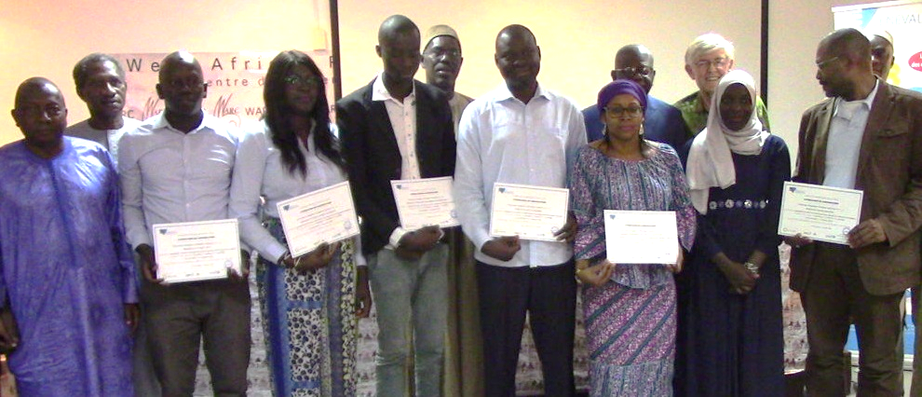

The meeting also served as a pretext to award prizes to the winners of a "*Mini-articles and Posters writing contest*", launched in December 2017 to promote scientific writing and encourage YEEs to perform applied research in evaluation. In the "mini-article" category, four authors were distinguished because of the relevance of their theme and their writing skills. Three were rewarded in the "posters" category. For Mr. Abdou Karim Lo, President of SenEval, "the organization of this competition is an innovation to be capitalized upon and sustained. SenEval is committed to providing the coaching needed to enhance award-winning works for publication in scientific journals". Mr Boubacar Aw, Coordinator of CLEAR Francophone, welcomed the collaboration and reaffirmed CLEAR's interest in supporting actions aimed at strengthening and promoting YEEs.

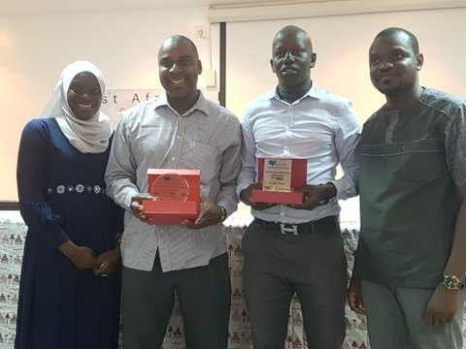

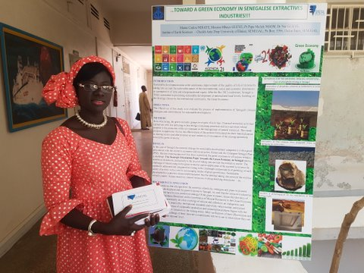

Find more information on the activity by reading the press articles below, or write to [amosmenard@gmail.com](mailto:amosmenard@gmail.com).

<https://www.lessentiel.sn/Suivi-evaluation-Le-SENEVAL-pour-une-meilleure-implication-des-jeunes-a-l-evalution_a6429.html>

<http://www.lerufisquois.info/?p=29339>